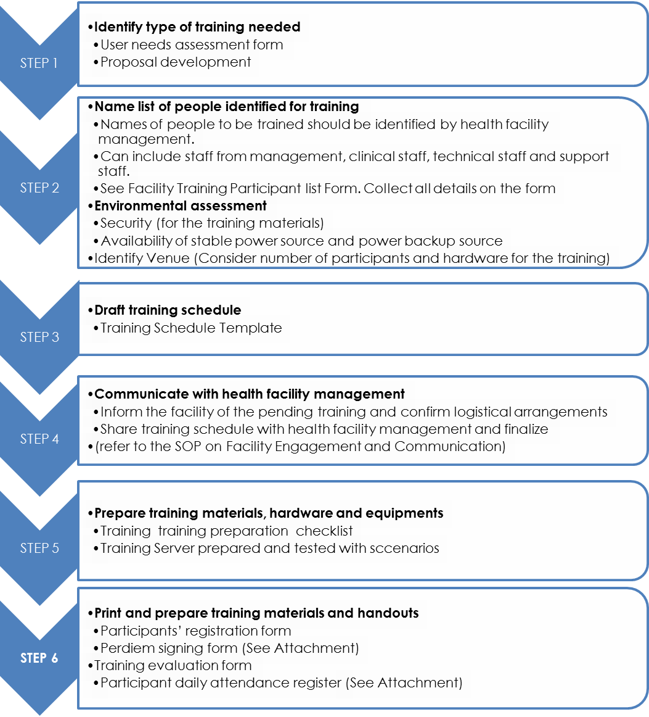
(See Attachment)
- PRE-TRAINING PHASE
Refer to the respective systems teacher’s guide

(See Attachment)
(See Attachment)
B. TRAINING PHASE
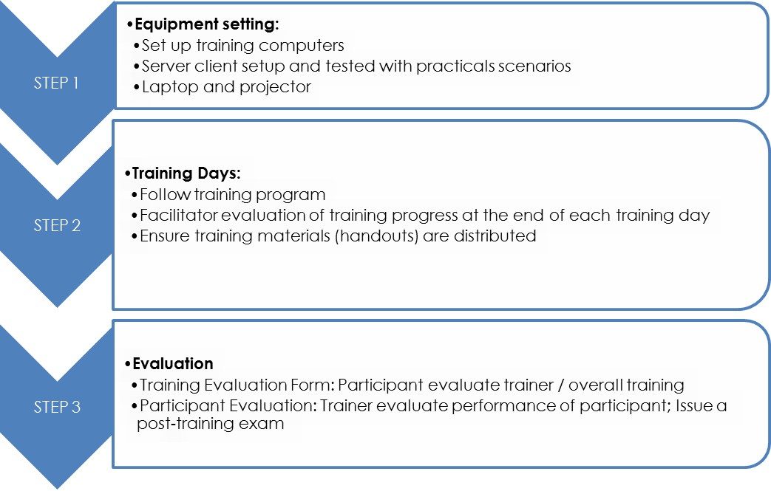
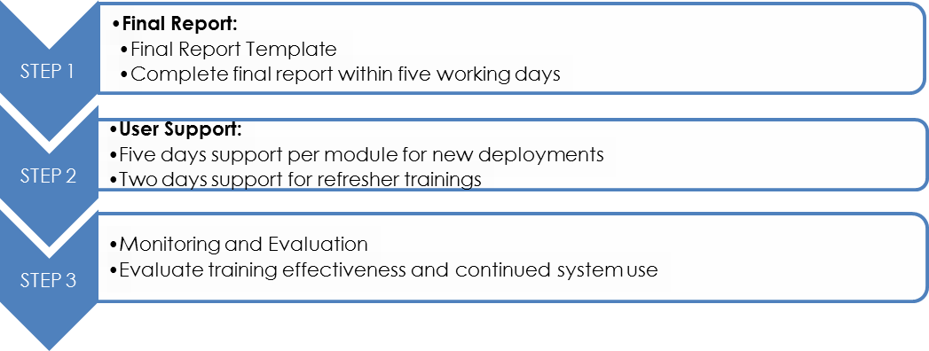
C. POST-TRAINING
(See Attachment)

